**WEB TECHNOLOGY WITH UI UX**

**ASSIGNMENT 1 – TASK 1**

**NAME: ZAHEEN KADRI ROLLNO: 50**

**CLASS: 4CEA BRANCH: CE**

**Step 1 - Click on New button to create a new repository**

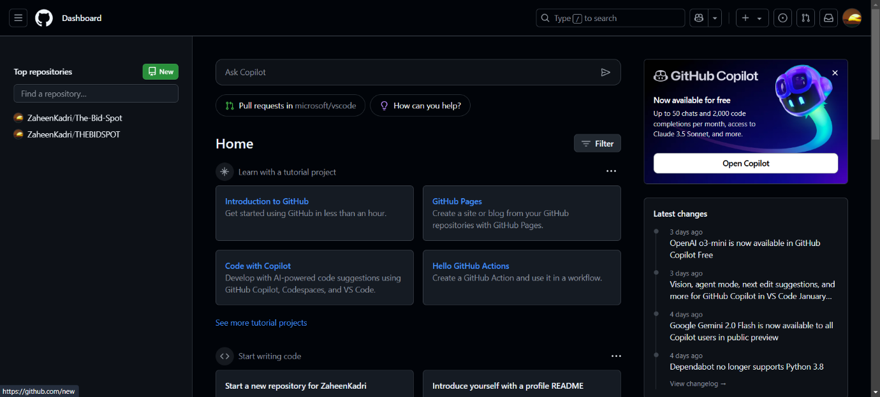

**Step 2 - In the Repository name field, enter your enrollment number**

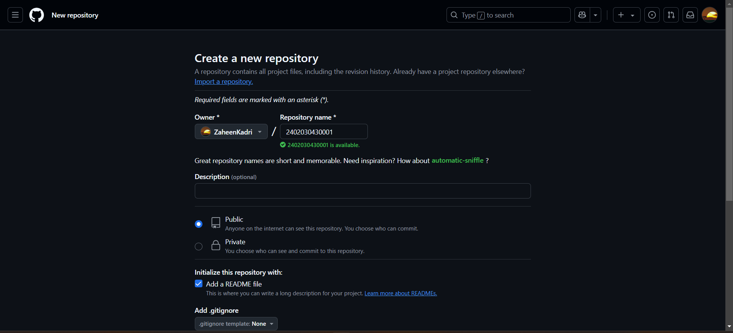

**Step 3 - Click "Create repository".**

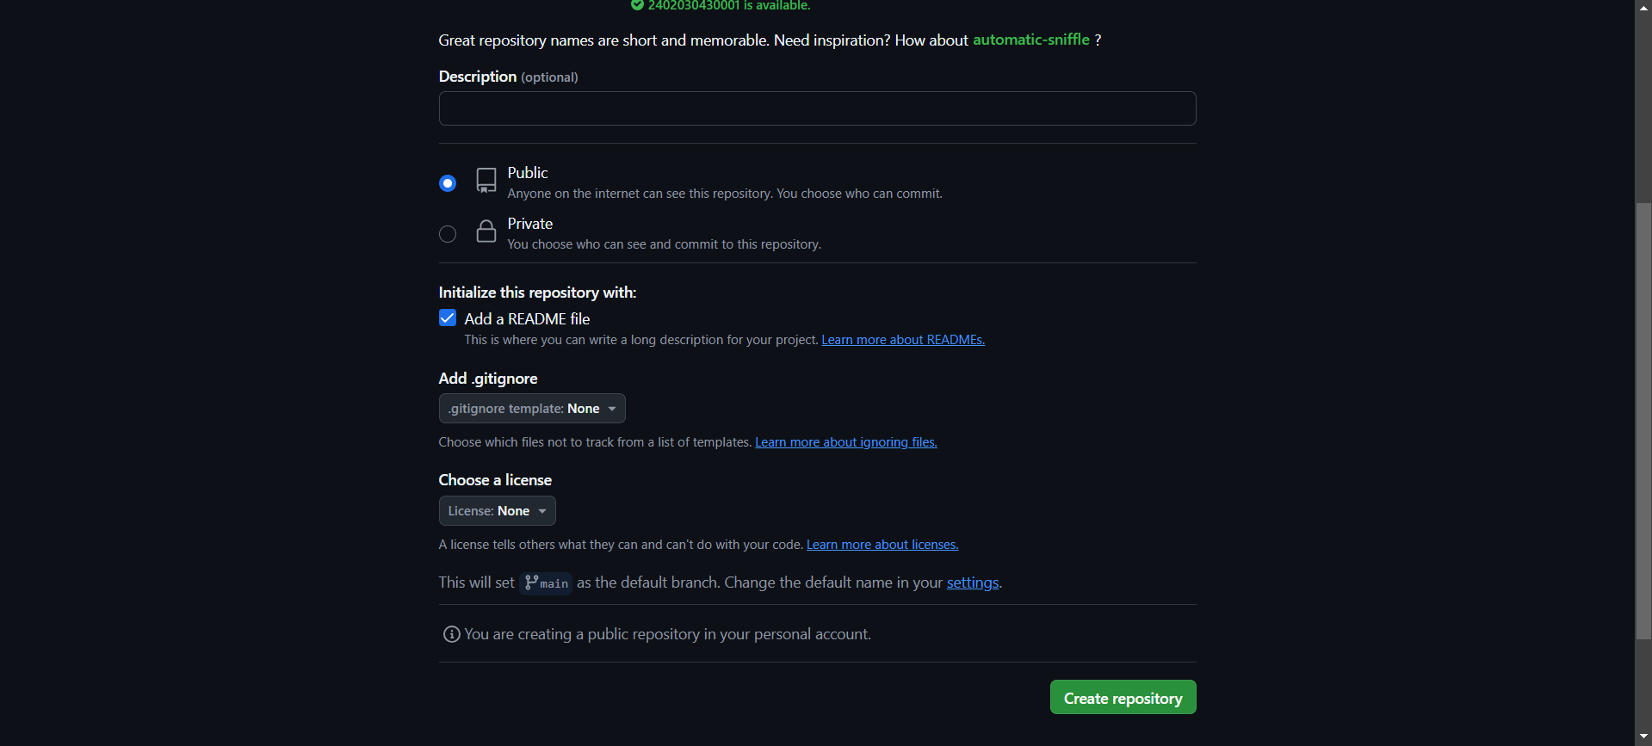

**Step 4 - Click the "Add file" dropdown, select "Create new file**

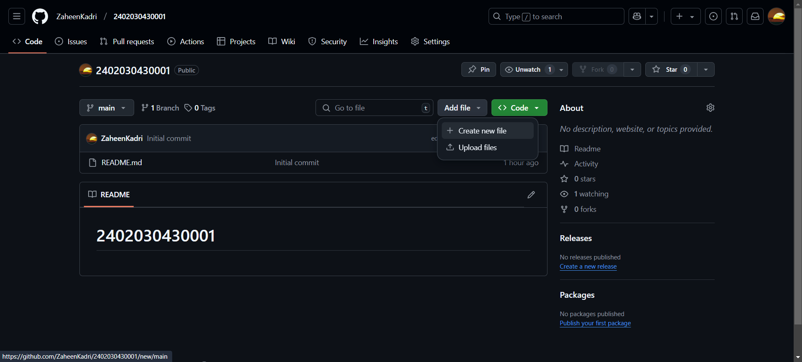

**Step 5 - Type the folder name followed by a slash (/) to create the folder structure and click on commit changes.**

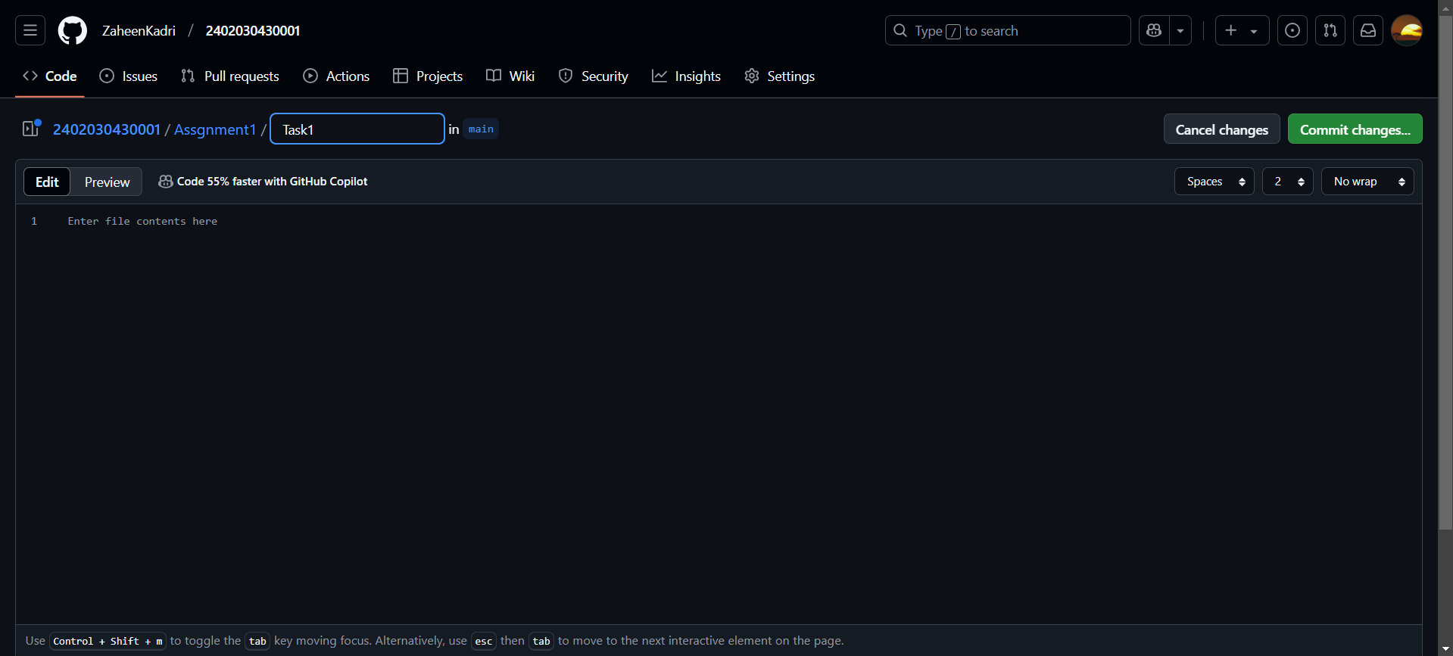

**Step 6 – Assignment 1 folder created**

